BEGINNING OF TERM ONE 2024
PRIMARY SEVEN
SCIENCE

Time allowed: 2hour 15 minutes

Name: ______________________________________________________________
School: _____________________________________________________________
FOR EXAMINERS USE ONLY
Read the following instructions carefully:
- The paper has two sections: A and B
- Section A has 40 questions (40 marks)
FOR EXAMINERS USE ONLY

Qn. No | MARK | SIGN
1  10
11  20
21  30
31  40
41  43
44  46
47  49
50  52
53  55
TOTAL

- Section B has 15 questions (60 marks)
- Answer ALL questions. All answers to both Sections A
and B must be written in the spaces provided.
- All answers must be written using a blue or black ball
point pen or ink. Diagrams should be drawn in pencil.
- Unnecessary crossing of work may lead to loss of marks.
- Any handwriting that cannot be easily read may lead to
loss of marks.
- Do not fill anything in the boxes indicated; For Examiners
use only.

Turn over

SECTION A (40 marks)
(Each question carries 1 mark)
1. Name the part of an insect used for feeding.
_____________________________________________________________________
_____________________________________________________________________
2. Give one element of weather.
_____________________________________________________________________
3. State any one property of air?
_____________________________________________________________________
_____________________________________________________________________
4. What is a forest?
_____________________________________________________________________
_____________________________________________________________________
5. How is soil formed?
_____________________________________________________________________
_____________________________________________________________________
6. Why are plants unable to make their food at night?
_____________________________________________________________________
_____________________________________________________________________
7. Give one way of controlling soil erosion in hilly areas.
_____________________________________________________________________
_____________________________________________________________________
Study the plant below and answer question 8 and 9.
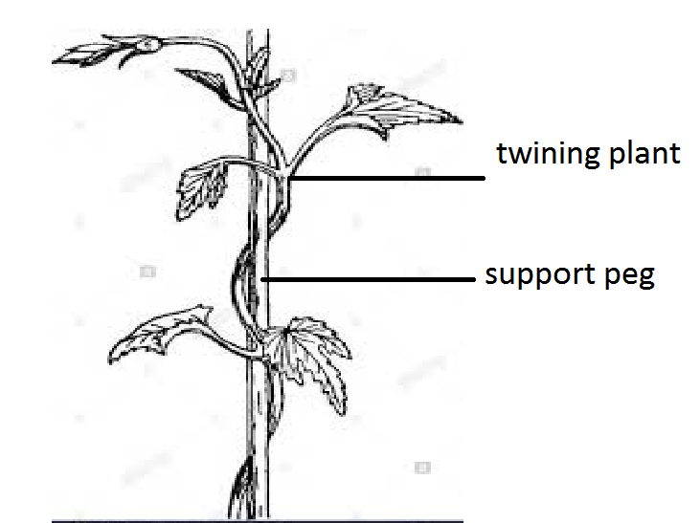

8. Why does the plant shown above climb other plants like trees?
_____________________________________________________________________
_____________________________________________________________________
9. How does the plant shown above climb other plants?
_____________________________________________________________________
_____________________________________________________________________
10. Why is it hard to hold a wet piece of soap firmly in our hands?
_____________________________________________________________________
_____________________________________________________________________
11. How is a maize fruit different from a mango fruit?
_____________________________________________________________________
_____________________________________________________________________
12. Mention the type of soil best for growing crops.
_____________________________________________________________________
_____________________________________________________________________
13. What stage in the life cycle of a cockroach is very dangerous to man?
_____________________________________________________________________
_____________________________________________________________________
14. Which word is used to refer to manufactured feeds for animals like rabbits?
_____________________________________________________________________
_____________________________________________________________________
15. In which condition of weather do plants lose water through their leaves?
_____________________________________________________________________
_____________________________________________________________________
16. Why is it dangerous to open a bottle of soda using your teeth?
_____________________________________________________________________
_____________________________________________________________________

17. What is the main natural source of water?
_____________________________________________________________________
_____________________________________________________________________
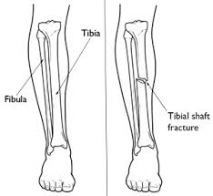
The diagram below shows a fractured leg of a human being. Study it carefully and answer question 18.

18. Name the type of fracture shown above.
_____________________________________________________________________
_____________________________________________________________________
19. Which aspect of wind is measured by a wind sock?
_____________________________________________________________________
_____________________________________________________________________
20. State any one disorder of the ear.
_____________________________________________________________________
_____________________________________________________________________
21. What role does water play in the process of germination?
_____________________________________________________________________
_____________________________________________________________________
22. How do most flowering plants reproduce?
_____________________________________________________________________
_____________________________________________________________________
23. How far should a pit latrine be from a water source?
_____________________________________________________________________
_____________________________________________________________________

24. Name one component of the solid part of blood.
_____________________________________________________________________
_____________________________________________________________________
25. What is the danger of taking drugs which are not prescribed by a health worker?
_____________________________________________________________________
_____________________________________________________________________
26. Why does a cork float on water?
_____________________________________________________________________
_____________________________________________________________________
27. Why are metals painted?
_____________________________________________________________________
_____________________________________________________________________
28. State any one immediate effect of alcohol to an individual who has taken it.
_____________________________________________________________________
_____________________________________________________________________
29. Which organ in the body is more affected by excessive smoking?
_____________________________________________________________________
_____________________________________________________________________
30. How does an invalid differ from a convalescent?
_____________________________________________________________________
_____________________________________________________________________
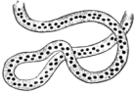
The diagram below shows eggs of an amphibian. Study it carefully and answer question 31.

31. Nam the amphibian that lays the eggs drawn above.
_____________________________________________________________________
_____________________________________________________________________

32. Mention any one value of immunization in a community.
_____________________________________________________________________
_____________________________________________________________________
33. Convert 40⁰C to ⁰F.

34. Why is a tick regarded as an arachnid?
_____________________________________________________________________
_____________________________________________________________________

The diagram below shows a musical instrument. Use it to answer questions 35 and 36.

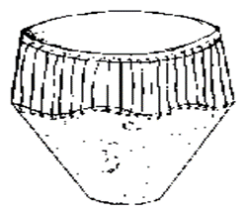

35. How does the instrument above produce sound?
_____________________________________________________________________
_____________________________________________________________________
36. To which group of musical instrument does it belong?
_____________________________________________________________________
_____________________________________________________________________
37. What basic units are used to measure mass of an object?
_____________________________________________________________________
_____________________________________________________________________
38. Suggest one way of controlling the spread of diarrhoeal diseases.
_____________________________________________________________________
_____________________________________________________________________
39. In which way can friction be reduced in hinges of doors and windows?
_____________________________________________________________________
_____________________________________________________________________
40. Mention one secondary sex characteristic in both girls and boys.
_____________________________________________________________________
_____________________________________________________________________

SECTION B (60 Marks)
(Each question in this section carries 4 marks)
41. The diagrams below show an equipment. Study them and answer the questions that follow.

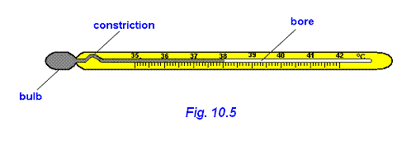
A
C
B

- Name the parts labelled
A ____________________________________
B ____________________________________
(b) How is part labelled C is important on the above instrument.
________________________________________________________________________________________________________________________________
(c) Why is mercury used in the above instrument than water.
________________________________________________________________________________________________________________________________
42. (a) What do you understand by Dual-purpose cattle?
________________________________________________________________________________________________________________________________
(b) Give two common local breeds of cattle kept in Uganda.
(i) ________________________________________________________________
(ii) ________________________________________________________________

The diagram below shows the shape of a type of cattle. Study it carefully and answer question (c)
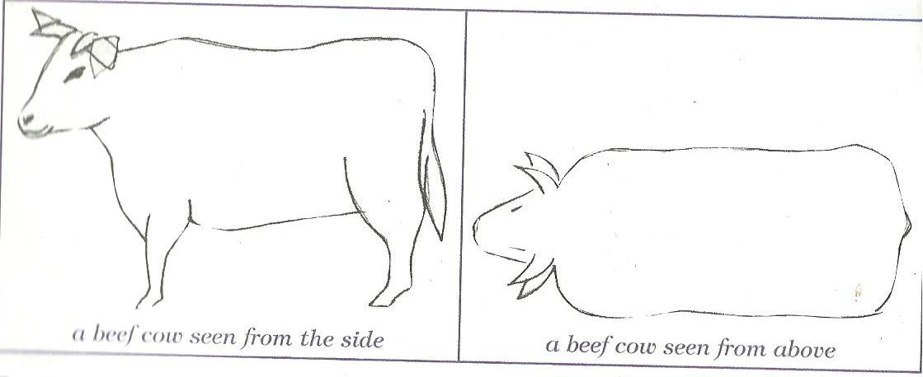

(c) What main product is obtained from the type of cattle with the shape shown above?
________________________________________________________________________________________________________________________________
43. State how the following animals protect themselves from enemies?
(a) tortoise _____________________________________________________
(b) wasp _____________________________________________________
(c) millipede _____________________________________________________
(d) chameleon _____________________________________________________
44. (a) In which units is frequency of sound measured?
________________________________________________________________
________________________________________________________________
(b) State the reason why sound should be stored.
________________________________________________________________
________________________________________________________________
(c) Mention one device used to;
(i) store sound: _____________________________________________________
(ii) reproduce sound: ________________________________________________
45. (a) Apart from carrots, state one example of root crops.
________________________________________________________________
(b) How are carrots propagated?
________________________________________________________________

(c) Mention any one root crop pest.
________________________________________________________________

(d) Suggest one way a farmer can control root crop pests.
________________________________________________________________
________________________________________________________________
46. (a) Name the type of organic manure got from animal wastes.
________________________________________________________________________________________________________________________________
(b) Write down any two advantages of compost manure.
(i) ________________________________________________________________
________________________________________________________________
(ii) ________________________________________________________________
________________________________________________________________
(c) How is frequent use of artificial fertilizers dangerous to the soil?
________________________________________________________________
_______________________________________________________________

47. Match the disease in list A to its cause in list B correctly.

 | List A (Disease) | List B (Cause)
(i) | Typhoid | Vibrio cholera
(ii) | Malaria | Salmonella typhi
(iii) | River blindness | Plasmodium
(iv) | Cholera | Onchocera vulvulus
 |  | Chlamydia

(i) Typhoid ____________________________________________________
(ii) Malaria ____________________________________________________
(iii) River blindness _______________________________________________
(iv) Cholera _____________________________________________________
48. (a) What is Primary Health Care?
________________________________________________________________________________________________________________________________
(b) Mention atleast two things emphasized in Primary Health Care.
(i) _______________________________________________________________
(ii) ________________________________________________________________
(c) Which element of Primary Health Care helps to control deficiency diseases in a community?
________________________________________________________________
49. The diagram below shows the reproductive organ of a cow. Study it carefully and answer the questions that follow.

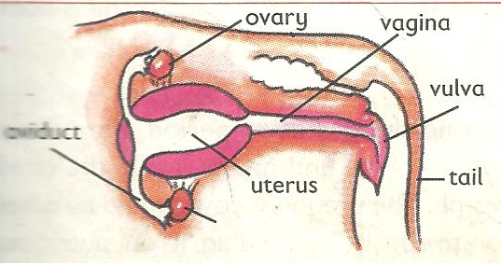
z

y

(a) Name the parts labelled Y and Z.
(i) Y ___________________________________________________________
(ii) Z ___________________________________________________________
(b) Where do the following processes take place in the diagram above?
(i) Implantation ________________________________________________
(ii) Fertilization ________________________________________________

50. (a) What is Agro-forestry?
________________________________________________________________________________________________________________________________
(b) Suggest one advantage of agro-forestry to;
(i) a farmer
________________________________________________________________________________________________________________________________

(ii) crops
________________________________________________________________________________________________________________________________
(c) Write the term used to mean the general planting of trees in an area.
________________________________________________________________
51. (a) Define a resource.
________________________________________________________________________________________________________________________________
(b) Mention any two types of resources.
(i) ________________________________________________________________
________________________________________________________________
(ii) ________________________________________________________________
________________________________________________________________
52. The diagram below shows the body part of a worm. Study it carefully and answer the questions that follow.

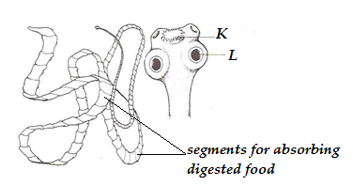

(a) Name the worm which has a head as shown in the diagram above.
________________________________________________________________
(b) Give the scientific name of the part labelled K.
________________________________________________________________

(c) State the use of part marked L to the worm.
________________________________________________________________
________________________________________________________________
(d) What does the worm shown above feed on?
________________________________________________________________
________________________________________________________________
53. Complete the table below correctly.
DISEASE | VACCINE | SITE OF IMMUNISATION
Tuberculosis | ____________________ | Right upper arm
Measles | Measles vaccine | ___________________________
__________________ | Polio vaccine | ___________________________
54. The diagram below shows a process of getting clear water. Study it carefully and answer the questions that follow.
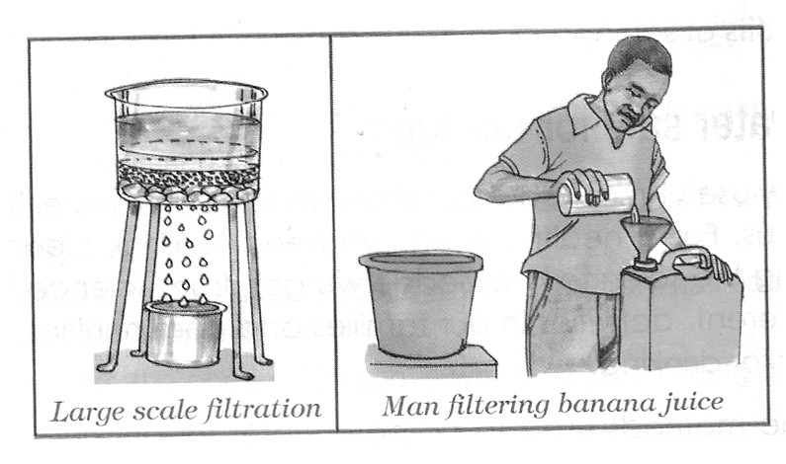
B

A

X

(a) Give the scientific name of substances marked A and B.
(i) A ___________________________________________________________
(ii) B ___________________________________________________________
(b) Why is it not advisable to drink water in container X?
________________________________________________________________
________________________________________________________________

(c) In what state of matter is water at 212⁰F?
________________________________________________________________

(d) How can we keep our body muscles healthy?
________________________________________________________________
________________________________________________________________
55. (a) What is known as Royal Jelly in apiary farming?
________________________________________________________________________________________________________________________________
(b) Apart from nectar, name any other material bees use to make honey.
________________________________________________________________
(c) Mention any two economic uses of honey.
(i) ________________________________________________________________
(ii) ________________________________________________________________

Good luck
P.7 Science Marking Guide B.O.T 2024
- Feelers/antennae
- Wind/sunshine
- Air has weight/Air can move (wind)/Air occupies space/Air is colourless/Air is not visible.
- A group of trees in one area/Trees standing together.
- Soil is formed by weathering of rocks and decomposition of matter.
- There is no sunlight at night.
- By digging terraces/Planting in strips (strip-cropping)/By planting/ploughing on contours/Contour ploughing.
- The plant shown above climbs other plants because it has a weak stem. (to get extra support)
- By using tendrils.
- because the wet soap and hands have less friction in between.
- A maize fruit is a grain while a mango fruit is a drupe/maize grows on a cob while a mango fruit grows on a stalk.
- Loam
- Adult
- Pallets
- Sunny weather
- It is dangerous because the bottle cap can break pieces off ones tooth. One can easily swallow pieces of broken bottle.
- Rain
- Simple fracture.
- Strength of wind
- Partial deafness/rapture of the ear drum.
- It dissolves food for the growing embryo/It softens the testa of the seed.
- By means of seeds.
- 30 metres
- Red blood cells/platelets/white blood cells.
- Taking over dose/taking under dose/taking a wrong drug.
- Cork is less dense than water.
- To prevent rusting.
- Loss of body balance/Forgetfulness/ loss of respect/poor judgment
- Lungs
- An invalid is a person who is seriously ill (sick) while a convalescent is a person who is recovering from an illness.
- Frog
- It reduces infant mortality rate/It prevents childhood killer diseases in children.
- ⁰F = (⁰C x ) + 32
= (40 x ) + 32
= (8 x 9) + 32
= 104⁰F.
- It breathes through book lungs/It has 4 pairs of jointed legs/It has two main body parts.
- Vibration of the skin when hit.
- Percussion
- Grams/Grammes
- Proper disposal of human excreta/wastes in latrines/Proper food hygiene/Boiling drinking water/Proper waste management/Serving food from clean utensils.
- By oiling/greasing/lubricating.
- Growth of hair around the pubic area and under armpits.
Section B
- 

- 
- Dual purpose cattle is a type of cattle kept for both meat and milk production.
- Boran/Nsanga/Ankole cattle.
- Beef
- 
- By hiding in its shell.
- By stinging
- By coiling
- By changing colour.
- 
- Hertz
- For remembrance/As evidence in courts of law/For future use/Fr commercial purposes.
- CD/DVD/ACD/Ipads/Cassettes/Flash discs/memory cards.
- MP3/VCD/Computers/radio cassettes players/Cello phones/projectors.
- 
- Cassava/sweet potatoes.
- By use of seeds.
- Squirrels/Moles/rats/eelworms/ caterpillars/potato weevil.
- Use of traps/crop rotation/bush fallowing/spraying or dusting/poisoning.
- 
- FYM (Farm Yard Manure)
- It increases soil depth/It improves soil texture and aeration/It improves soil fertility and structure/It improves on water holding capacity.
- It destroys soil structure and texture.
- 
- Salmonella typhi
- Plasmodium
- Onchocera vulvulus
- Vibrio cholera
- 
- Is essential health care/Prog where individuals, families & communities work together to solve their common health needs.
- Equal care for all/Prevention rather than cure/prioritizing health needs
- Food and nutrition.
- 
- Y  uterus Z  vulva
- (i) Uterus (Part Y)
(ii) Oviduct
- 
- Agroforestry is the growing of crops together with trees on the same piece of land.
- (i) gets double income.
(ii) get shade/rain
- afforestation.
- 
- Anything used for a purpose.
- Renewable/Non-renewable.
- Sunshine can be replaced naturally when used up.
- 
- Tape worm
- Scolex
- To suck/absorb food
- Digested food.
- 
BCG, left upper arm, polio, mouth
- 
- A  Residue B  Filtrate.
- Because it contains germs/It is not clean.
- In gaseous state.
- 
- Is the food on which the queen bee feeds in a hive.
- Pollen grain/water
- For sale to get income/Used in industries/ it is medicine.

